Palantir Dataset Exports Guide (ICHNT) – Creating/Updating a Java DataBase Connectivity data connection task(for a SQL server on premises data connection)

Begin exploring or creating a pipeline in the ‘projects’ space which is where any development (data engineering) within Palantir happens (a project has to be created before any engineering pipeline can be built).
This is the URL for the ICHNT (Imperial College Healthcare NHS Trust) projects space:
https://icht.palantirfoundry.co.uk/workspace/compass/projects
Palantir/ICHNT has created (for its engineers) a sandbox (project) with owner level permissions
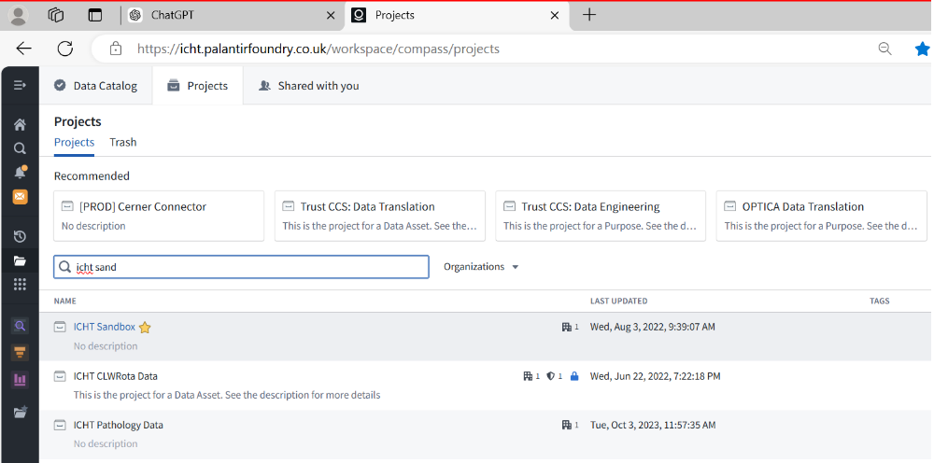
On entering the project folder looking to the right hand side we can see that the current user has owner level permissions
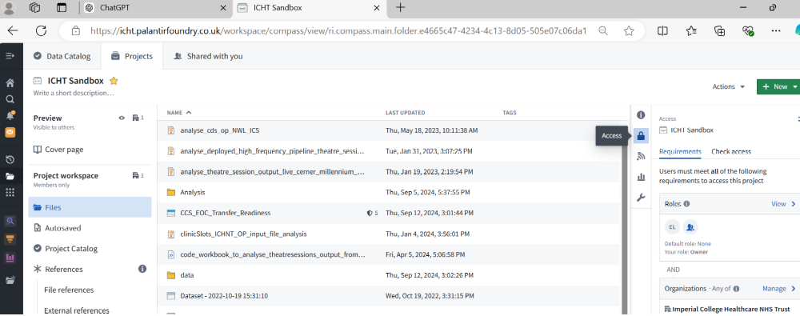
Assuming that a pipeline has already been built to export data from Palantir Foundry into an external organisation’s data warehouse Navigate to the dataset which is being exported currently.
In this example it is the dischargelogOptica3 dataset which is being routinely exported to an external data warehouse and you can see that I have downloader and owner properties/rights as a user on that dataset:
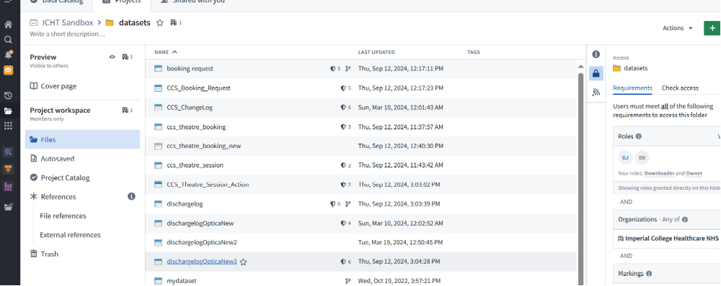
By clicking on the dischargelogOptica dataset we can review the properties of that dataset.
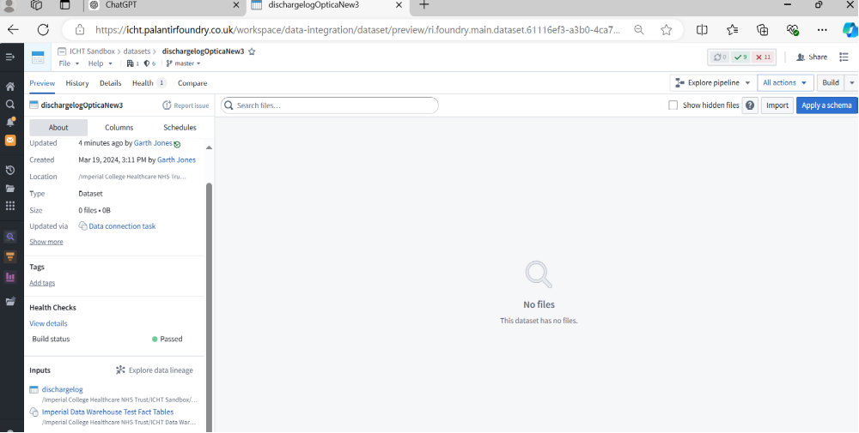
You should be able to see who created the (export) dataset/connection, you should also be able to see when it was last updated and you should also be to see (importantly) how it is being updated, namely by a data connection task – note that this is an OUTBOUND SQL server JDBC dataset connection task meant to write data from PALANTIR to the ICHT ssql server data warehouse, if you look at the bottom of the image (left hand side) you can see the small cloud and database icon hinting that the JDBC Source which is being used (already set up in Palantir) is the 'Imperial data warehouse test fact tables'(as a JDBC source this source is actually a connection directly into a specific database on the imperial Trust SQL server datawarehouse namely the Palantir_Cert database in server SQL_CNRDW-STGE\inst3 (as at 12/09/24) so a Palantir engineer has already set up that data soucre which can be used by the data connection object to pipe data into the trust warehouse, and we need to focus on and understand this data connection task we also need to have a look at the dischargelogOptica3 dataset in the data lineage tool (aka monocle), because by viewing the dataset in that tool we will be able to see the full pipeline and how the dataset is created from source to destination.
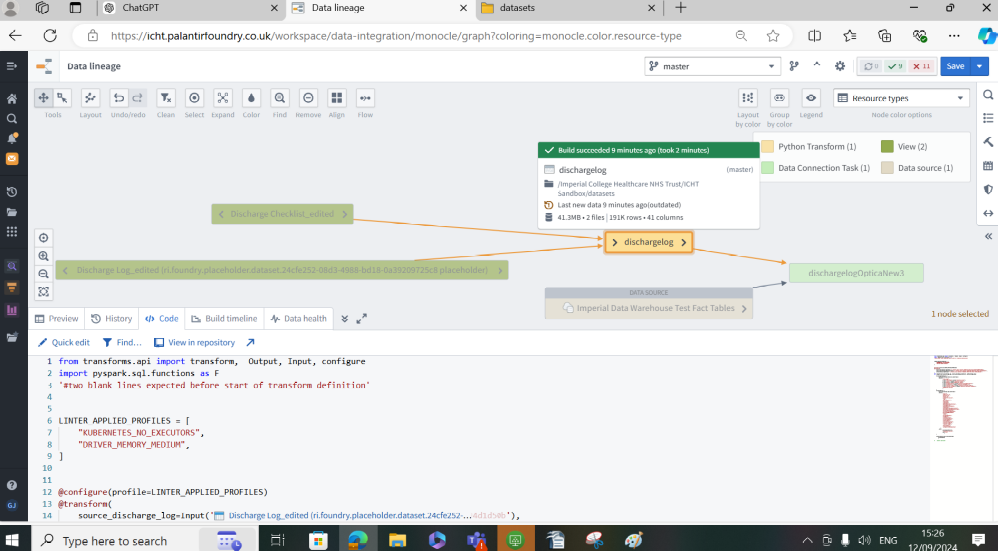

Subsection – creating a new data connection task (from an existing SQL server JDBC data source)
Note*: if you need to create a new data connection task against an existing data source, you need to display the data source in the data lineage tool and right click on the data source and select 'create new data connection' , *also when creating a new data connection and defining the 'outputDataset' you must click 'new' when stating the file location because it will be a new output file.*

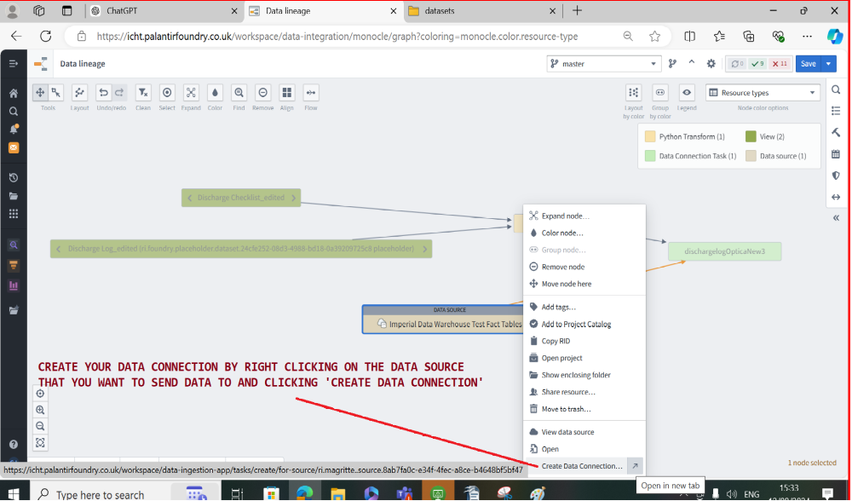

Having created a new data connection in another tab we complete the configuration details of the new data connection (input/output) and the schema configuration, note that in the connection here even though 'data sourc' is stated really for the data connection in this example (because the data connection that we are defining is outbound) really the data source is acting as a data destination.
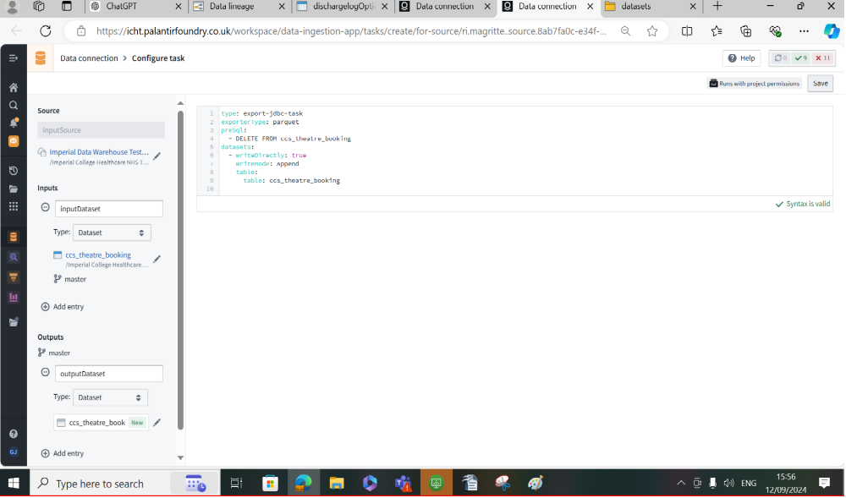
*note the 'new' in green bottom left of the data connection object output reference denoting a new output to the data source (acting as a data destination)
Having accurately stated the config (and the data warehouse table to write our to and delete) we can save the settings.
Once the connection task has been created – click into it and build it (and debug where necessary – e.g. (incorrect column types/column lengths are too short/column type of arry causes problems so remove using a pyspark transform/table in sql server does not match schema of data connection/table in palantir) then the connection will need to be scheduled to run routinely (and you can do this in the data lineage tool) using the scheduler pon the right side.

Referencing source tables in from other projects
If your data connection is referencing datasets from other projects you must reference that dataset in your sandbox (create a reference to that project in your sandbox) or else the data connection will not have the necessary permission to connect to that dataset in order to export it:

the settings of an existing data connection task examined
By going in to the properties of an existing data connection task we can see the various settings, parameters and configurations necessary in order to export the dischargelogOptica3 data connection (note the dischargelogOptica3 is primarily actually a data connection object).
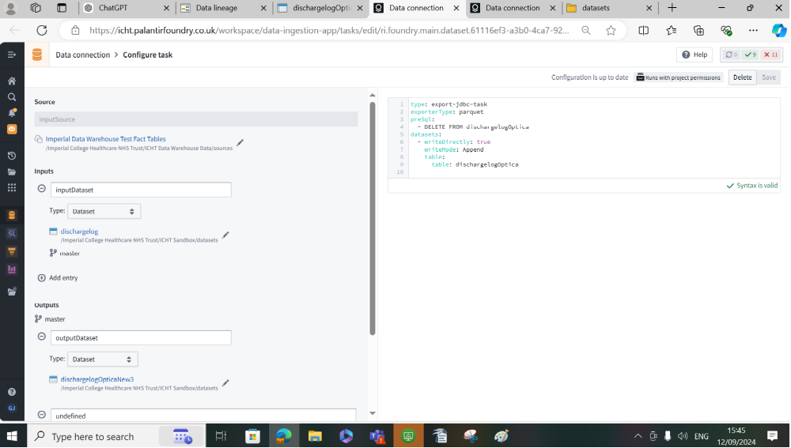
Notice the ‘inputsource’ which is defined/created as a JDBC data source under the ‘data connection’ application in Palantir, this is a data connection object (to a specific server and database within the external organisation) which must be created before a data connection task is created. Note also that an account with read/write permissions must be created for Palantir to connect and write data to a table on that server within that database.
The Input dataset (there must be at least one) must be named only ‘inputDataset’ as a convention – note the case sensitivity – and a file location of a source (input dataset) must be stated.
The output dataset (there must be at least one – see image below) must be named only ‘outputDataset’ as a convention – note the case sensitivity – and a file location of a destination (output dataset) must be stated*note! when creating a new data connection and defining the 'outputDataset' you must click 'new' when stating the file location because it will be a new output file.*
Finally having stated the JDBC data source (which needs to have been created already), the input (source) dataset, the destination (output) dataset we need to define the configuration and parameter settings which in the example are:
type: export-jdbc-task
exporterType: parquet
preSql:
- DELETE FROM dischargelogOptica
datasets:
- writeDirectly: true
writeMode: Append
table:
table: dischargelogOptica
In this case we’re connecting to a JDBC (java database connectivity) data scource (pre-defined) and therefore the export type is ‘export-jdbc-task’
The file to be exported is type ‘parquet’ which is the standard Palantir Foundry ‘big data’ file format.
The sql to be executed (on the client side) before the data append/export is executed is to delete all current contents of that client side table (on this case ‘dischargelogOptica’)
The dataset ‘write’ settings are set to append and writedirectly = true and the target table in the client server/database is defined as being dischargelogOptica.

Note that the configuration file above assumes that a table/dataset has been created in the database (defined in the data source connection) on the client side, that table in this example is dischargelogOptica and this was the SQL used to create that table on the client server/database:

drop table PalantirFoundryRYJ_Cert.[dbo].[dischargelogOptica]

CREATE TABLE PalantirFoundryRYJ_Cert.[dbo].[dischargelogOptica](
[log_id] [varchar](1000) null,
[admission_id] [varchar](1000) null,
[patient_id] [varchar](1000) null,
[status_id] [varchar](1000) null,
[checklist_task_id] [varchar](1000) null,
[type] [varchar](1000) null,
[previous_value] [varchar](1000) null,
[new_value] [varchar](1000) null,
[timestamp] [datetime2](7) null,
[updated_by] [varchar](1000) null,
[plannedDischargePathway] [varchar](1000) null,
[fundingSource] [varchar](1000) null,
[plannedDischargeDate] [datetime2](7) null,
[subPathway] [varchar](1000) null,
[plannedDischargeDestination] [varchar](1000) null,
[plannedDischargeDateConfirmed] [varchar](1000) null,
[dischargeCaseworker] [varchar](1000) null,
[actualDischargePathway] [varchar](1000) null,
[escalatedManagement] [varchar](1000) null,
[status] [varchar](1000) null,
[assigneeGroup] [varchar](1000) null,
[assigneeDetails] [varchar](1000) null,

[taskNotes] [varchar](1000) null,
[isTimeCritical] [varchar](1000) null,
[transferDiagnosis] [varchar](1000) null,
[acceptingDoctor] [varchar](1000) null,

[referralDate] [datetime2](7) null,

[transferConsultant] [varchar](1000) null,

[transferringFrom] [varchar](1000) null,

[transferringTo] [varchar](1000) null,

[dateTransfer] [datetime2](7) null,

[transferNotes] [varchar](1000) null,

[autogeneratedSubpathway] [varchar](1000) null
)

Having reviewed the ‘data connection task’ and the settings therein necessary for exporting a file from Palantir Foundry to an external client server/database (using a JDBC task) as noted above it is also essential to review the dataset which you are trying to export (in this case the file dischargelogOptica) in the data lineage tool. So return to the properties of the dataset for export within the project folder and click on ‘explore data lineage’:

You should be taken to the data lineage layout and be able to review/see the full pipeline of objects involved with the export of the dataset, from source file, to any python transforms involved in formatting the file prior to export, the data connection task and the JDBC data source/destination which the file is exported to. Note: don’t be confused by the arrow pointing from the JDBC source to the green data connection task, the arrow actually should be pointing the other way because the data flow is actually out to the JDBC source (which is here actually acting as a destination).

Pay attention to the ‘resource types’ legend which shows in a colour scheme the various objects involved.
The dischargelog python transform in this example is our starting point because the writeback dataset and ‘discharge log’ Python Transform were created by Palantir engineers as being the source data for export, the dischargelog python transform on the right was created by ICHNT engineers in order to export a specific subset of columns and avoid a column of datatype ‘array’ which although being fine for Palantir Parquet files cannot be exported to an SQL server database/dataset using the JDBC export task. There are probably ways to transform columns of type ‘array’ into acceptable sql server formats but in this example the python transform simply excludes that column.
To look at the code written in the python transform click on the transform and select the code tab at the foot of the data lineage page tool web page:

You should be able to see that the ICHNT engineers created a simple transform to define exactly which columns should be output into the dischargelog dataset output from the transform here: /Imperial College Healthcare NHS Trust/ICHT Sandbox/datasets/dischargelog which then becomes the source for the ‘data connection task’:
'#from pyspark.sql import functions as F'
from transforms.api import transform, Input, Output
'#two blank lines expected before start of transform definition'

@transform(
source_discharge_log=Input("ri.foundry.main.dataset.6a0be177-b25e-4c14-815d-05a094d1d50b"),
outdischarge_log=Output("/Imperial College Healthcare NHS Trust/ICHT Sandbox/datasets/dischargelog")
)
def compute(outdischarge_log, source_discharge_log):
dischargelog = source_discharge_log.dataframe()
dischargelog = (
dischargelog
.select(
"log_id",
"admission_id",
"patient_id",
"status_id",
"checklist_task_id",
"type",
"previous_value",
"new_value",
"timestamp",
"updated_by",
"plannedDischargePathway",
"fundingSource",
"plannedDischargeDate",
"subPathway",
"plannedDischargeDestination",
"plannedDischargeDateConfirmed",
"dischargeCaseworker",
"actualDischargePathway",
"escalatedManagement",
"status",
"assigneeGroup",
"assigneeDetails",
"taskNotes",
"isTimeCritical",
"transferDiagnosis",
"acceptingDoctor",
"referralDate",
"transferConsultant",
"transferringFrom",
"transferringTo",
"dateTransfer",
"transferNotes",
"autogeneratedSubpathway"
)
)

outdischarge_log.write_dataframe(dischargelog)

# return source_df

Note that Palantir Foundry Pyspark transforms are created in Code Repositories (a code repository needs to be created within a project before the Pyspark transform can be created in the code repository and form part of the pipeline in the data lineage). The creation/coding of Pyspark transforms within a Palantir Foundry code repository as part of the data export process is addressed in appendix 1 within this document.

Appendix 1: Creating a first (Python/Pyspark) transform in Palantir

The first thing to do is navigate within Palantir to your project folder and within that project folder create a (sub) folder within which to hold your Transform objects, in the snapshot taken from the Palantir Foundry training video below you can see the engineer creating a folder to hold the Transform objects and note the convention that the work ‘Transform’ is used at the beginning of the folder name:

Now that the sub folder has been created to hold the transforms, we now need to go into that folder and create a ‘code repository’ – Question for discussion: does this mean that a ‘code repository’ is created for and associated with a specific project folder? It seems that the code repository is created within the new ‘transform’ folder.
So within the new ‘transforms’ folder find the green ‘New’ drop down on the top right hand side and select ‘Repository’ from the ‘New’ drop down list:

When you create the repository you will see an ‘initialisation’ screen and within that screen you can name the repository and you can also select the language of choice for that code repository (in this case python), in the example below we name the repository ‘Transform Examples’ and we choose the code in the repository to be Python. Question for discussion: In this example we are creating a new code repository within a project, but how do we enter an existing code repository that has already been create within a project?

With the code repository now created/initialised, we’re now in the code respository which seems to be a kind of Integrated development Environment (IDE) within which we can create our Python Transform objects. The creation of a Python Transform object in Palantir is done using an existing dataset/transform template, so to begin with on the left hand side within the file/object explorer expand the folder structure and under the subfolder ‘SRC’ click on the 3 dots next to the folder called ‘dataset’

On clicking the 3 dots you will get the option to create a new file – select this

When the new file screen is presented enter a name for your transform and be sure to include the .py file extension (which means it’s a python file), also be sure to select the ‘Python transform’ option from the drop down list below. When you do this a Python Transform template file will automatically be generated for you, when you click on ‘create’:

We now have a python transform template created within our transform sub folder (within the main project), now we need to find (within the main project folder) a suitable datasource for the transform – notice here we are assuming that a suitable data source for the transform has already been created within the project (within the project folder). We will now (within the code repository IDE) navigate through the main project folder to find a suitable pre-created data source that can be referenced within the transform using the folder/file location (within the main project), so on the top left hand side of the Code repository Toolbar select the 3 dots, and you will see two folders from which to choose: the current sub folder for the transform objects and the overarching main project folder – choose the main project folder because we need to find a suitable data source within the main project folder:

Clicking on the 3 dots and selecting the project folder opens a new ‘explorer’ tab within which to explore the main project folder to find a suitable (pre-created) datasource – notice that the code repository tab is not closed.

Unsurprisingly the datasource object (which has previously been created) is found in a datasource project sub folder (under the main project folder) – this highlights a convention within Palantir that just as Transforms are held within Transform project folders in Palantir, so Data sources (which feed the transform objects) are held within Datasource project folders, and so in this example the ‘ready-made’ data source object is sourced from the ‘Flight Control system’ data source project folder:

Going into the flight control system datasource folder for this project, it looks as though each dataset (or entity) within the flight control system data model has its own folder, so there are 5 different folders for 5 different data model entities: airport, flight alerts, flights, route alerts, runways. These are all different concepts and different datasets within the flight control system data model and therefore Palantir seems to have a convention for a different project sub folder for each dataset:

We choose to select the flights folder (and the therefore the flights datasource/dataset) and further select the ‘clean’ flight dataset folder, notice that within the ‘clean’ folder not only do we have the cleaned (and therefore probably final) data source for flights but in that folder are also the reference data for the flights concept/datasource – this seems to be another Palantir convention (to have the necessary reference data tables for a concept within the same datasource folder as that concept). And the important and relevant detail here is that when we select the ‘flight’ data source on the right hand side within the properties window we can copy the location of that datasource, for that datasource address will be pasted into the transform as denoting the datasource file location:

Having copied the file location string of the flight data source we now select the ‘code repository’ ide tab again (leaving the project explorer folder tab open for now) because we want to continue building our Python Transform within the code repository and specifically we are going to replace the “source_dataset_path” placeholder in the Python Transform template code with the actual file path of the data source which we just copied, so look to the following line of code:
Source_df = Input(“SOURCE_DATASET_PATH”)
And replace the string “SOURCE_DATASET_PATH” with the actual file location string which you just copied from the flight datasource:

When you paste the location of the flights datasource you should see that the file location is replaced by a little dataset icon and the name of the datasource together with a random looking alphanumeric string:

Next what you might like to do is change the default variable name of the dataframe using the datasource (in this case the default name is ‘source_df’) we will rename the dataframe created from the flights datasource to a more meaningful dataframe name, in this case ‘flights’, so now the dataframe created within this Python transform from the flights datasource is actually calls ‘flights’. But (and here is in an important point) if you rename the dataframe used within the Python Transform from the default source_df, you must also rename the reference to that dataframe in the ‘compute’ function below, because the compute function in the Python Transform will ordinarily take your dataframe do something with it (i.e. computations or changes to that dataframe/transform it) and then return it to you, so if you don’t change the reference name here also it won’t be able to refer to that dataframe. And so in the screenshot below you can see that not only have we change the default dataframe variable name to ‘flights’ in the variable attribution statement within the code, but we have also changed the dataframe reference to ‘flights’ within the ‘compute’ function

At this point all we’ve done is point to an established datasource within the Palantir project folder, assign that datasource to a dataframe variable called ‘flights’, push that ‘flights’ dataframe into a function called ‘compute’, do nothing with it and then simply return it to the user. You might think: ‘what is the point in doing that?’ because nothing has been done with that dataframe/dataset: it hasn’t been transformed. That’s a good point BUT the point of this exercise is to do a very simple transform by way of introduction called ‘an identity transform’ where the input is identical to the output.

Notice that in the transform the invocation/reference of the pyspark.sql package and the functions therein has been commented out and insofar as that ‘#’ sign remains we cannot invoke or reference the pyspark.sql functions in order to write scripts within the ‘compute’ function to exact changes to the dataframe. Notice that this is the convention within the Palantir Python transforms, namely to use pyspark.sql and the functions therein to change the input dataset/dataframe into another form (add derived columns/format columns/delete columns/execute joins etc.) all of these transformative actions are generally achieved using pyspark.sql. Note that the pyspark.sql package is a package of python code specifically designed to manipulate/change dataframes on a distributed computing platform such as the big data Apache Spark environment to leverage the power and speed of the Apache spark big data processing engine and distributed computing power to transform very large datasets at speed.
We therefore need to uncomment the reference to the pyspark.sql package in order to be able to reference and used the functions that belong to that package and begin to transform the dataframe using pyspark sql commands.

Now that we have uncommented the reference to the pyspark.sql functions we can now call on those functions and use them to start transforming the dataframe.
The following lines of code use the powerful ‘withcolumn’ function and also the ‘concatenate_ws’ function and ‘col’ function to create a new column in the flights dataframe called ‘date’ and this is a concatenation of the existing year, month and day columns with a hyphen placed between each dimension featuring in the concatenation.

from pyspark.sql import functions as F
# use the withcolumn function of flights pyspark dataframe to create a new column called date
# use the concat_ws function of the pyspark.sql functions library to concatenate the year, month and day
# columns placing a hyphen in between each dimension
flights = flights.withColumn("date", F.concat_ws("-", F.col("year"), F.col("month)", F.col("day_of_month")))

This completes an initial example of using pyspark within Palantir to create a Python transform and add a derived column called ‘date’.

Having created a derived column in the transform we can now look at bringing a reference table as another input into the transform and creating a separate dataframe from that datasource input called ‘carrier’ (I would be more inclined to call the table ‘carrier_lookup’), note that the process of adding this additional data input is similar to what we did for the ‘flights’ data input (you need to copy the file reference for the datasource). This ‘carrier’ data source is actually a lookup/reference table to get the reference name for carrier codes, and in order to check that the carrier code column is suitable to execute a join we should navigate to the data source, double click on the datasource to open it and then on the appropriate column click the drop down and select ‘ analyse stats’, we can see an example of doing that with Trust’s Care Coordination Solution by navigating to the NM_IPWL_PLUS_RTT2 table (in the ‘raw’ data folder within that project) and opening that table:

Then I select an appropriate key field to join on and review the stats for that column by selecting the drop down against the column and clicking on ‘view stats’ (in this case we select the ‘encounter’ column):

When the stats for the key column I’m reviewing are visible, at the bottom right is a histogram giving me a count (ordered descending) of the number of times each unique value occurs in that column, and because the count is ordered descending if there were duplication values I would see it straight away. I can also check for the presence of nulls/missing values on the left. Recall that the two fundamental properties of a key field need to be: unique and not null.

To return to the flight control system we can see that an appropriate column has been selected from the flight and carrier tables to join over, also note that the function ‘join’ by default is an inner join (but you can explicitly state left, right or outer if preferred), here the default ‘inner’ join is used:

Creating a multi output transformation:

A multi output transform builds on the more simple Palantir transforms which result in a single output dataset to a transform which results in several output datasets. The transform builds on the default transform template but with a few changes to the code:
- We use the ‘transform’ object instead of ‘transform_df’ object
- In the transform declaration section of the code we have to state multiple outputs with different variable names and different file location names (in addition to stating inputs)
- We have to not only pass the input dataframes as variables into the ‘compute’ function but we also have to pass the output variables into the ‘compute’ function
- Unlike the simpler transform we have to explicity declare/create the creation of the input dataframes within the ‘compute’ function.
- Also unlike the simpler mono-output ‘transform_df’ object we have explicity state the ‘write’ of the output objects instead of just using the return statement.
Finally make sure having changed the code in the template to result in a multi output that you press ‘build’ on the toolbar above to debug the code and commit the changes to the transform. In the example below you can see that the default simpler Transform code has been changed to use ‘transform’ instead of ‘transfrom_df’ and that multiple outputs are being explicitly stated: output1 and output2 (which end up being physically saved in the project folder as simple_transform and second_transform’ files/objects/datasets) these two objects should be visible on the data lineage – note that these outputs from the multitransform are separate and distinct objects from the transform itself

Snapshot showing the results of a multioutput transform (two inputs and two inputs) on the data lineage – note the highlight of the multi transform in relation to the two inputs and two outputs:

